* Motor shield 可以看做一个adaptor，可以用matlab控制UNO board实现控制motor的目的。
* 烧录的程序目前有三个，a mymou训猴的部分 b 控制motorshield部分 c Ian的adio

实现arduino分时控制两路外设

硬件：ARDUINO UNO/ Motor shield/ blue tooth /kamoer pump/cell phone or tablet/

软件：matlab/Arduino 1.8.8

原理：收到蓝牙信号1，控制channel#2输出TTL控制某阀门（待设计），

收到蓝牙信号2，控制channel#12输出TTL控制泵水

收到蓝牙信号2，控制channel

## pellet dispenser

摘要：设计一款可以实时检测猴子，执行任务并给与固体颗粒奖励的装置，

硬件：使用pad输出实验刺激，feedback是否奖励，蓝牙+arduino，光电感应器用来检测一次成功的食物掉落，motorshield控制stepper的运动

软件：mymou+arduino code

开发记录：

* 8月11日以前，只能工作10个trial（[code：](sketch_test-time-logic/sketch_test-time-logic.ino)），后来简化程序，减少打印输出后，工作时间在100+trial，但是仍然会有breakdown的记录，过程中会伴随motorshield的芯片发热，使用外设电源为（[亿森能12V锂电池组大容量 9V5V移动电源A品18650芯户外监控音响灯带可充电动力电瓶-tmall.com天猫](https://detail.tmall.com/item.htm?id=652964280040&spm=a1z09.2.0.0.22992e8do0Hvaw&_u=f2674646ec4&sku_properties=149128818:1044370296)） 的12Vout1输出端为Arduino供电，12vout2为sensor（[原装欧姆龙光电开关U型槽型EE-SPX303N EE-SPX403N传感器带1米线-淘宝网 (taobao.com)](https://item.taobao.com/item.htm?spm=a1z09.2.0.0.22992e8do0Hvaw&id=645982353705&_u=f267464981c)）供电
* 8月12日，三块arduino板子，发生不能下载任何程序的故障，其中一块电脑不能在硬件管理器里识别，另外两块可以的(已标记)。
* 8/15日开始，troubleshooting

1. 确认arduino的数字端的输入电压值：less than 5v
2. sensor读取的coding part （[constants - Arduino Reference](https://www.arduino.cc/reference/en/language/variables/constants/constants/)）！
3. Sensor的电路改装，之前电阻为220欧姆，今调整为1K欧姆

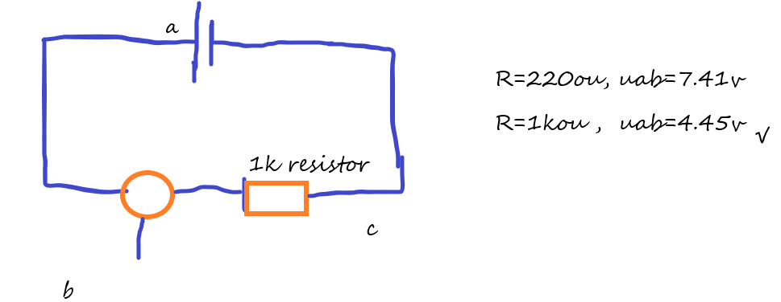

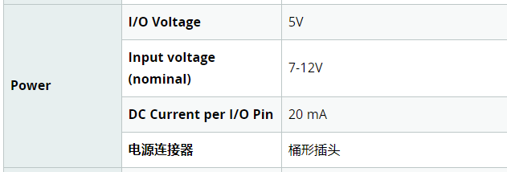

1. 电源端输入的调制:暂时使用usb
2. 更换一个板子之后的Coding download的情况：
3. StepperMotorBT √
4. A0forOmiron √
5. Final ×
6. Timelogic ×
7. 测试coding 的功能情况
8. StepperMotorBT
9. PAD（SumSung T580，COGP#2），basic+shrinking coding，可以连续工 作40+trials，然后就不工作，如果插拔蓝牙之后，会重新开始工作。
10. Android phone+SPP， 没有出现不工作的情形。
11. testTimeLogic
12. sensorVal =digitalRead(7); 写在 if (sensorVal==LOW) {}之内时，motor通电时间过短，导致不工作
13. sensorVal =digitalRead(7); 写在if (currentMillis - previousMillis >= delaylegnth) {}之前，motor可以工作。还没有测到sensor是否工作。
14. 8/19 使用final.info 测试，可以读数字口，但并能保证每次都能阻止motor的继续转动，。Pad还是有运行十几个trial然后，停止运行的问题，需要插拔蓝牙接口。
15. 禁止在串口上的打印输出之后，不会再出现pad连不上蓝牙的问题了，最后download的程序是test_milliseconds
16. 最后的调试和封装：

电源使用：12v/5v，杜邦线改为螺丝式，15公分的电源不能放在装置里边。

1. 转盘有抖动的现象，原因待查，怀疑是每次上电或者反转的时长过短造成的。

2022/8/29 使用新收到的同款motorshield+motor+stepper Motor_BT , 可以工作

另一款马达，收到蓝牙后会又抖动，前进，后退等动作，原因待考，怀疑使用的数字电路的名字与上一台不一样，但是烧录的是motor_BT的程序，需要找到该马达的详细资料。

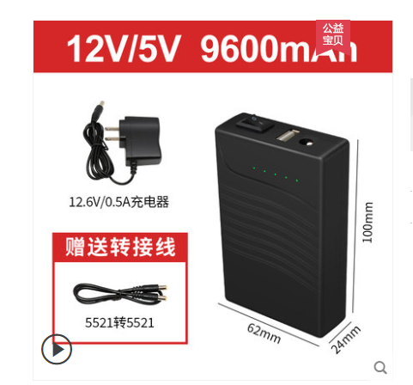

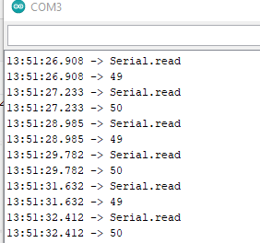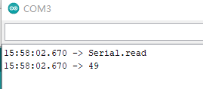

1. pad工作时串口输出的内容 b.手机工作时串口输出的内容

参考文献：

### Pins Configured as INPUT

Arduino (ATmega) pins configured as INPUT with [pinMode()](https://www.arduino.cc/reference/en/language/functions/digital-io/pinmode) are said to be in a high-impedance state. Pins configured as INPUT make extremely small demands on the circuit that they are sampling, equivalent to a series resistor of 100 Megohms in front of the pin. This makes them useful for reading a sensor.

If you have your pin configured as an INPUT, and are reading a switch, when the switch is in the open state the input pin will be "floating", resulting in unpredictable results. In order to assure a proper reading when the switch is open, a pull-up or pull-down resistor must be used. The purpose of this resistor is to pull the pin to a known state when the switch is open. A 10 K ohm resistor is usually chosen, as it is a low enough value to reliably prevent a floating input, and at the same time a high enough value to not draw too much current when the switch is closed. See the [Digital Read Serial](http://arduino.cc/en/Tutorial/DigitalReadSerial" \t "https://www.arduino.cc/reference/en/language/variables/constants/constants/_blank) tutorial for more information.

If a pull-down resistor is used, the input pin will be LOW when the switch is open and HIGH when the switch is closed.

If a pull-up resistor is used, the input pin will be HIGH when the switch is open and LOW when the switch is closed.

### Pins Configured as INPUT_PULLUP

The ATmega microcontroller on the Arduino has internal pull-up resistors (resistors that connect to power internally) that you can access. If you prefer to use these instead of external pull-up resistors, you can use the INPUT_PULLUP argument in [pinMode()](https://www.arduino.cc/reference/en/language/functions/digital-io/pinmode).

See the [Input Pullup Serial](http://arduino.cc/en/Tutorial/InputPullupSerial" \t "https://www.arduino.cc/reference/en/language/variables/constants/constants/_blank) tutorial for an example of this in use.

Pins configured as inputs with either INPUT or INPUT_PULLUP can be damaged or destroyed if they are connected to voltages below ground (negative voltages) or above the positive power rail (5V or 3V).

### Pins Configured as OUTPUT

Pins configured as OUTPUT with [pinMode()](https://www.arduino.cc/reference/en/language/functions/digital-io/pinmode) are said to be in a low-impedance state. This means that they can provide a substantial amount of current to other circuits. ATmega pins can source (provide current) or sink (absorb current) up to 40 mA (milliamps) of current to other devices/circuits. This makes them useful for powering LEDs because LEDs typically use less than 40 mA. Loads greater than 40 mA (e.g. motors) will require a transistor or other interface circuitry.

Pins configured as outputs can be damaged or destroyed if they are connected to either the ground or positive power rails.